**10.1 HUMAN RESOURCE MANAGEMENT**

Human Resource Management (HRM) focuses on providing directions, recruitment and management of the people who work under an organization. All processes and programs that people is assigning to or is assigned to will be under the HRM surveillance. HRM department members are to provide the knowledge, necessary tools, training, administrative services, coaching, legal and management advice, and talent management oversight, which is vital for the successful operation of the rest of the organization (Heathfield, 2017).

There are four main processes that are contained in HRM, which are:

* Plan Human Resource Management
  + The process of forecasting the future human resource requirements of the organization, and determining the organization’s utilization of existing human resource (Juneja, 2018).
* Acquire Project Team
  + The process of selecting and approving human resource availability according to the list of required skills to obtain the team necessary to complete the project tasks (My Management Guide, 2018)
* Develop Project Team
  + The process of improving internal and external interactions between team members, developing their competencies and skills, as well as optimizing the overall team environment to increase project performance (My Management Guide, 2018)
* Manage Project Team
  + The process in which team members’ performance are tracked, as well as using feedback, resolving strategic and operational issues, and managing changes to optimize project performance (My Management Guide, 2018).

**10.1.1 Issues Involved in HRM**

|  |  |  |  |  |
| --- | --- | --- | --- | --- |
| **Human Resource Management** | | | | |
| **Issue No.** | **Issues** | **Project Management Process** | **Tools & Technique** |
| 6 | There was redundancy of work performed as the Work Breakdown Structure (WBS) was done separately by each respective department and the Project Manager did not review and then consolidate those WBSs into one wholistic WBS | Initiation | **Pre-Assignment**:  Assigning teammates to work on tasks following the WBS and provide regular updates to the project manager. |
| 7 | Most of the team members have been focusing more on their daily operation support rather than tasks being assigned by the Project Manager or their respective Team Lead | Execution | **Performance Reviews**:  Conduct a daily check routine to ensure the project plan is being followed and ensure the team members are doing their task as provided. |
| 13 | There was no clear project organizational structure to manage the project. | Planning | **Organization Chart**:  With organization chart, clear organizational structure is developed start from the highest management till the individual responsibility. |

As stated in the above table, the issues that are needed to be emphasized upon are issue No.6, 7, and 13. The first stated issue, **ISSUE NO.6**, for the discussed management for Human Resource is that there was a lack of tasks being completed, as each department disregards the consolidation proposed in the Work Breakdown Structure, and as such did not refer to any other departments in performing their tasks. In order to solve this issue, the management can devise **Pre-Assignment**, in which teammates would be assigned to perform tasks while also adhering to the Work Breakdown Structure. This could be achieved by allocating staffs based on their specialties, and have them completing the tasks given in accordance to other departments as well. The project manager will also be updated on the progress of the tasks on a regular basis.

Another issue that needs to be considered is **ISSUE NO.7**, in which the team members have their focus diverted, by having them working on daily operation support instead of performing tasks given out by their higher-ups. This could very well lead towards the delay of the project as a whole, as their time management will go awry if left unsupervised. As a way to resolve the mentioned issue, the human resource management can organize **Performance Reviews**, that allows the management to perform a check routine in order to monitor the team members. Each team member will be supervised, and actions will be taken if certain members did not adhere to the assigned tasks accordingly. This method will also take the supervision of the project plan into consideration, so that each department will adhere to the provided plan.

Human resource management will also need to emphasize on **ISSUE NO.13**, which states that the project organizational structure was vague, and as such, throws the organizational structure into chaos. As such, the human resource management need to create an appropriate **Organizational Chart**. This should ensure that each team member is fully aware of their positions and tasks, and will act according to the said chart. The organizational chart need to provide a well-established structure, starting at the top of the hierarchy in terms of organizational position, all the way to each individual member with their respective responsibilities.

**10.1.2 Plan Human Resource Management**

The planning of the management of human resources is crucial, as it corresponds directly to the success of the whole project management. The plan is to clearly lay out the guidelines on how the human resources should be allocated for the project management, which includes the staffing, managing, supervising, and discharging of human resources. The identification of skills required in team members for the project team is also included in the plan, as there is a need to utilise the plan in order to ascertain various training strategies for the members (Project Management Institute, 2013).

Therefore, it is essential that the project manager should take initiative in determining the set of skills required in team members for each task that has been determined for the project. Based on the skills determined, the project manager can then determine further details, which comprises of the following: The expertise required, the task to be assigned, the time period for each task, the amount of resource needed, and the estimated cost of resource. These details will ensure that the project will have enough human resources to complete the project, as well as sufficient resources can be acquired within the budget given.

For the matter of ISCMP, the details of the required expertise, the assigned tasks, and the amount of time for each task to be completed has been laid out in the Gantt chart. It is therefore vital hat the human resource management plan is carried out, as the project requires members that are proficient in their respective fields, particularly the software engineers and the UI engineers. This is because the tasks for the project will not be outsourced, save for the software tester, communication officer and procurement officer. The project will be dependent on the team members’ proficiency that has been approved by the project manager. This has also led to more reasons that the project manager should allocate resources to train the team members to polish their skills in their department.

Once the team members are briefed of their specific tasks, supervision are to be executed. The project manager is to take initiative into monitoring the members’ progress, as well as their utilization in both their work time, and the resources used to complete the tasks. The quality control department is also responsible in this regard, as they are to determine the quality of the output as the team members are working on the product. This supervision will ensure that the performance of the team members is kept under control, as well as being able to determine the ones who perform well, enabling the supervisors to endorse them with suitable rewards, thus encouraging them.

**10.1.1.1 Project Organizational Chart**

An organizational chart is a diagram that presents the hierarchical structure of an organization (RFFlow Electronics, 2016). As for this project, the hierarchical structure will be represented as a matrix chart. Instead of choosing between lining up staff along functional, geographic, or product lines, the matrix chart consists of both. Team members can report to a functional manager who can aid in tasks, as well as to a product line manager who sets the direction on product offerings.

With the utilization of the matrix chart, resources can be used more efficiently, as experts and equipment can be shared across projects. Products and projects are also formally coordinated across functional departments. As team members are in contact of many people, this aids in the sharing and flow of information, speeding up the decision process. In addition, team members are to work autonomously and do some self-management between their competing bosses, which can increase their motivation and decision making.

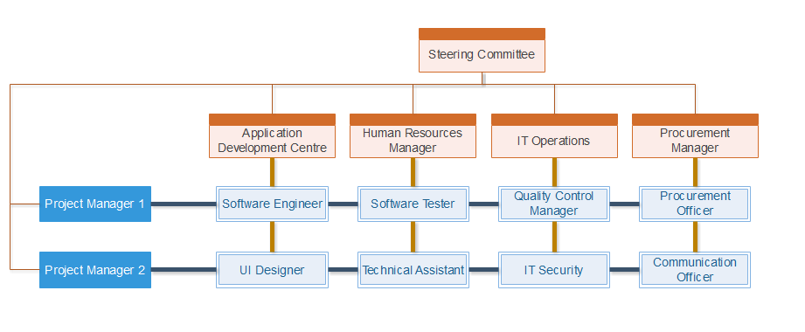

**10.1.1.2 RACI Chart**

A RACI (Responsible, accountable, consulted and informed) chart is a matrix of all the activities or decision making authorities undertaken in an organization set against all the people or roles. Therefore, this has enabled the possibility of assigning somebody responsible, accountable, consulted, or informed at each intersection of activity and role.

A RACI analysis is essential for workload analysis, as when work overloads can be quickly identified. It is also possible for a re-organization to ensure that key functions and processes does not go unnoticed. In addition to allowing duties to be distributed effectively between groups and individuals, the management can also provide a means of resolution of inter-departmental conflict.

|  |  |  |  |  |  |  |  |  |  |  |  |
| --- | --- | --- | --- | --- | --- | --- | --- | --- | --- | --- | --- |
| **Tasks/Role** | **SC** | **PM** | **PMA** | **SE** | **UD** | **HRD** | **ST** | **QCM** | **TA** | **CO** | **PO** |
| System Proposal | R |  |  |  |  |  |  |  |  |  |  |
| Feasibility Studies |  | R, A | C |  |  |  |  |  |  |  |  |
| Project Charter | C | R, A | C |  |  |  |  |  |  |  |  |
| Project Plan | I | R, A | C | C | C | C |  | C |  |  |  |
| Human Resource Plan | I | C | C | C | C | R, A |  | C |  |  |  |
| Financial Plan | I | C |  |  |  | C |  | C |  |  | C |
| Quality Plan |  | C |  |  |  |  |  | R, A |  |  |  |
| Communication Plan |  | C |  |  |  |  |  |  |  | R, A | I |
| Procurement Plan |  | C |  |  |  |  |  |  |  | C | R, A |
| Requirement Gathering | C | I |  | R | R |  |  | C |  |  | I |
| Procurement |  | I |  | C | C |  |  |  |  | R | R, A |
| Staff Management |  | I |  |  |  | R, A |  |  |  |  |  |
| Development |  | I |  | R | R |  |  |  |  |  |  |
| Testing |  | I |  |  |  |  | R, A | R |  |  |  |
| System Setup |  | C |  | R | R |  |  |  | R |  |  |
| Documentation | I | R |  | C | C | C | C | C |  |  | C |

|  |  |
| --- | --- |
| **Code** | **Role** |
| SC | Steering Committee |
| PM | Project Manager |
| PMA | Project Manager Advisor |
| SE | Software Engineer |
| UD | UI Designer |
| HRD | Human Resource Department |
| ST | Software Tester |
| QCM | Quality Control Manager |
| TA | Technical Assistant |
| CO | Communication Officer |
| PO | Procurement Officer |

|  |  |
| --- | --- |
| **Code** | **Meaning** |
| R | Responsible (one who performs the task) |
| A | Accountable (one who is accountable to the task) |
| C | Consulted (one that needs to feedback and contribute to the task) |
| I | Informed (one that needs to know of the decision/action) |

**10.1.1.3 Resource Histogram**

Resource histogram is a visual representation that is usually used by the project management team, in order to provide the details of the amount of time used for a specific resource to be worked on over a predetermined time period (Project Management Institute, 2004). Resource histogram proves to be useful as it can allow the project management team to easily view the available resources, which resources are being used at the moment, as well as the amount of time taken for the resource to be in task.

**10.1.1.4 Motivational Theory**

In order to keep team members motivated and productive throughout the project, it is important for the project manager to be acquainted with motivation theories that will aid in the efficiency of the team members, thus increasing the quality of the project output. These motivation theories can also inspire team members to take action and become self-directed (Papa, 2017). Below are the several models of motivational theories.

**Maslow’s Hierarchy of Needs**

The hierarchy of needs theory was developed by Abraham Maslow in 1943, in his paper “A Theory of Human Motivation” (Mark, 2014). This model identifies one’s needs on a progressive pyramid, starting from the most basic needs to the least basic needs. The theory implies that when motivating, only unsatisfied needs can be fulfilled, rather than fulfilling already satisfied needs. It is also noted that team members can be motivated by having the management meeting their most basic human needs and building on them (Papa, 2017). The diagram below represents the five needs that Maslow has identified.

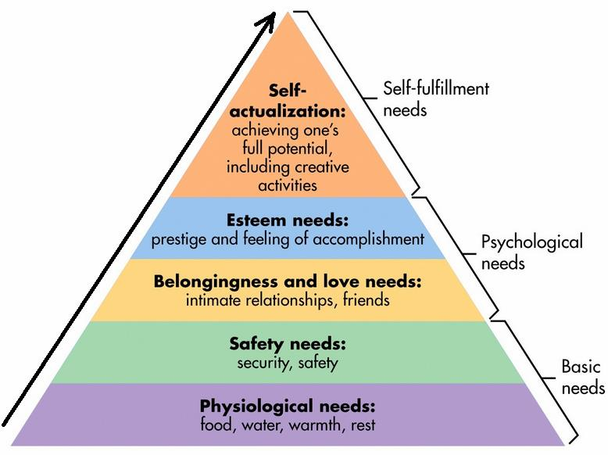

**Herzberg’s Two Factor Theory**

Coined by psychologist Frederick Herzberg in the 1950’s (Mark, 2014), this factor theory identifies two main sources of motivation for the people involved in the workforce. The first being **hygiene factors,** which involves in the working environment, the salary, the job security, as well as the style of management. These lack in these factors can lead to the employees’ dissatisfaction, leading to the lowering of motivation in work. The second factor is **motivator factors,** which is basically satisfying the employees to motivate them. These motivations relate to their achievements, status, recognition, responsibility, and potential growth. Simply put, with the increasing in this kind of factors, the employees will be more motivated in their tasks (Papa, 2017).

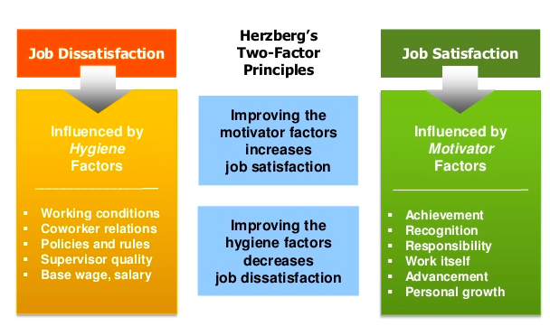

**10.1.3 Acquire Project Team**

This process involves in the obtaining specific people that is essential for the completion of all the phases of the project. The finalized team members would fulfil all of the specific requirements with their qualifications and abilities that they can contribute to the project. Usually, the project team is made by having the project management team filtering and selecting from the available candidates (Project Management Institute, 2004).

Acquiring project team is not without criteria to adhere to. It is vital that the project management team refer to these criteria as guidelines when selecting team members for the project.

**Level of experience** – The project management team needs to analyse information regarding the current level of experience of team members for the project, and compare it to their required level of experience.

**Level of interest** – The project management team is to assess the team members’ enthusiasm in participating in the project.

**Personal qualifications** – The project management team needs to evaluate each team member’s skills and talents for them to qualify into the involvement of the project, as well as their compatibility with other team members.

**Availability** – The project management team collaborates with the functional managers, and identifies the potential team members’ availability for the project.

**Knowledge** – The project management team assesses the team members in terms of their competency and proficiency (My Management Guide, 2018).

**10.1.2.1 Negotiation**

This method can allow the project management team to assign staffs between multiple project sections, so that each section of the project will have proper amount of human resources in its disposal within the given time frame (My Management Guide, 2018). In this case, the project management team will need to make negotiations with the other project managers in order to be provided with additional team members. The management should also be able to make an approach to others, as the means to execute this plays a large role in the negotiation with staffs in regards to the assigning of their tasks.

The project management team can negotiate with the functional managers regarding the staffs’ work time, as well as their salary for the duration of the project. In addition to this, the management team can also request for extra staff from GL (if needed), without having to make more expenses on the budget.

**10.1.2.2 Acquisition**

While most requirement for the projects are fulfilled by team members, there will be certain roles that need to be carried out from external sources, as the available resources are not suitable for the specific roles (Learn Certification, 2015). In this case, there is a need in external opinion on the developed application for the project – which is why there is a need in software testers in order to test-run the software prototype.

**10.1.4 Develop Project Team**

This process involves in the improvement of competencies, interaction between team members, and overall team environment in order to boost the performance of team members during the execution of the project (Project Management Institute, 2013). The development of the team members will result in the improvement in terms of teamwork, skills, motivation, and project performance as a whole.

**10.1.3.1 Tuckman Model**

First coined by psychologist Bruce Tuckman in his 1965 article “Developmental Sequence in Small Groups”, he came up with the phrase “**forming, storming, norming** and **performing**”. This phrase is to describe the steps that most teams adhere to in achieving excellent performance in their project. It was only later that Tuckman added another stage in the sequence, namely “**adjourning**” (MindTools, 2016).

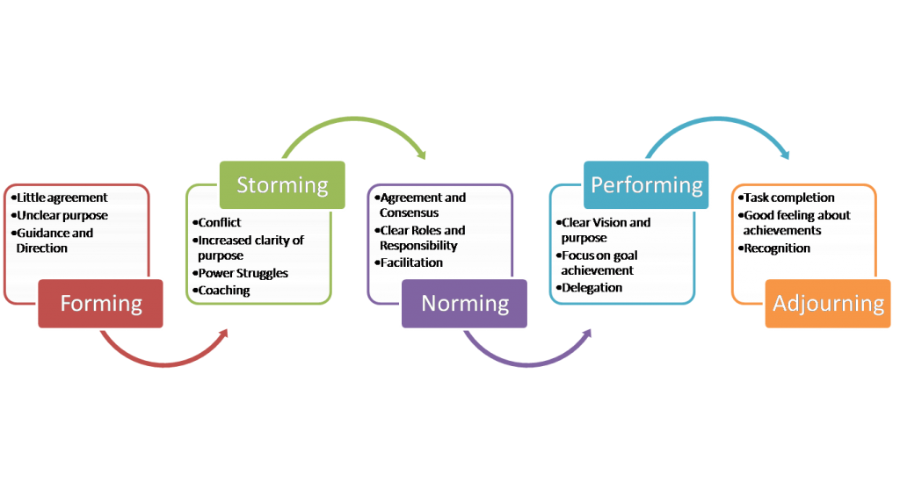

**Forming**

This starting stage usually presents team members as being positive and polite, as they try to create a good first impression towards others. While some may appear anxious since they are not familiar with the project, most should appear to have some enthusiasm in the upcoming tasks for them (MindTools, 2016). As different people have different sociability, it may take some time for the team members to get used to each other, as well as putting effort in establishing a personal identity within the group (Mullins, 2010).

On this stage, the project manager should take charge in directing the team, as well as establishing clear objectives for both the overall team and individual team members.

**Storming**

The next stage is the storming phase, in which members will be presented with conflict among each other. The conflict can be stemmed from multiple reasons, one of it being that the working styles of members differ from each other. Not being used to others’ work style means that members usually cannot synchronize with them, and as a result, may cause unexpected problems in the future. Other reasons include members challenging higher authorities, competing for positions, feeling overwhelmed by workload, or feeling uncomfortable with project manager’s approach. At this point of the stage, team members may experience a degree of stress, as they have not strongly bonded with the other members, and not have the support of established process (MindTools, 2016).

By this point, the project manager should take initiative in establishing processes and structures for the team members. The project manager should also supervise the team members as they build trust and good connections with each other, as well as resolving any conflicts that might occur. Another activity that the project manager can take part in is to use psychometric indicators, for example, the Myers-Briggs Type Indicator (MBTI) to assess and aid the team members of their work styles, strengths, and weaknesses (MindTools, 2016).

**Norming**

During this stage, team members should be accustomed to each other, in which they start to resolve their differences, acknowledge others’ strengths and weaknesses, and respect the higher authorities. As such, team members should be able to mix and socialize together, as well as help each other where needed. Thus, members will be committing towards the goal as a team, and will be able to advance in a progressive manner.

During this stage, it is best that the project manager should step back and aid team members in taking in responsibility for their progress on their tasks for the project (MindTools, 2016).

**Performing**

The performing stage should present with the team members performing their tasks well, without any resistance, towards the completion of the overall project. The project manager can entrust tasks to the team members without worry, and can focus on the development of the team members. As the team’s structure is stable, members who join nor leave will neither affect the performance of the team as a whole.

As stated, the project manager can assign tasks and projects as far as possible. The project manager can now be able to divert their attention towards other goals and areas of work that needs attention (MindTools, 2016).

**Adjourning**

This final stage will be reached by team members ultimately. It is at this stage that a team finally wraps up their work and then dissolves, once the team has fulfilled their goals and objectives. It is important that the team is dissolved on appositive note. Members may exhibit a sort of mourning, as they feel a sense of loss when the group comes to an end. In addition, members may also display some uncertainty or insecurity about their future after the project ends (Swarthout, 2015).

Thus, it is essential for team members to be recognized for their achievements and celebrate the team’s overall success. By viewing past experiences positively, members who might work with each other again will have an easier time synchronizing back together again (MindTools, 2016).

**10.1.3.2 Myers-Briggs Type Indicator**

Personality tests can help in the identification of the potential skills of team members, therefore allowing managers to advantageously and strategically position members that match their potentials. The Myers-Briggs Type Indicator (MBTI) personality types reviews the research on understanding the personality traits possessed by competent members. It defines the 16 MBTI types, and which of them were most likely to perform the tasks and responsibilities assigned in accordance to the position with proficiency. Furthermore, it clarifies on the functions of the MBTI system, as well as listing the MBTI types that suitable enthusiasm in respective to different positions (Gehring, 2007).

**10.1.3.3 Team Building**

Team building involves in the process of taking a collection of individuals with different needs, backgrounds, skills and knowledge, and transforming them by various means into a unified and effective work unit. The transformation process merges the goals and energies of individual members, supporting the objectives of the team as a whole (David L. Wilemon, 1983).

A simple yet effective team building activity would be to host a pizza party. Generally, as food brings people together, this activity can provide members an avenue where they can start talking and sharing. At this point, they will begin to see each other in their roles from a different perspective. Another advantage of this activity is that it is simple enough to be planned and held on a more regular and consistent basis. This will further encourage team members to connect with each other, gaining each other’s trust and solidifying their relationship.

**10.1.3.4 Reward and Recognition**

The reward and recognitionsystem’s main purpose is to ensure that team members feel appreciated and that their work has not gone unnoticed. Besides that, it also serves as an excellent way of pushing team members to do better and better over the course of the project life cycle. As such, each member should be aware of the reward and recognition system so that they can continuously try to achieve for the same rewards. Hence, team members will have a reason to improve themselves in their work, further motivating them towards the project goal (Dwevedi, 2017).

As part of team-building, individual members can express on how they would prefer to be recognized and rewarded. Since members will likely differ in what motivates them, the team can decide on how to show recognition in any outstanding work by any member and how to celebrate achieving milestones. The project manager should also inquire members on how they would like to be rewarded. Recognition is appreciated most when it is timely, specific, and personal, and such, the project manager should be alert for opportunities and not hesitate in offering a simple note or word of appreciation (Bullwinkle, 2016).

**10.1.5 Manage Project Team**

To manage project team is to track team members’ performance, provide feedback, resolve issues, and manage team changes to optimize project performance. This process impacts team behaviour, manages conflicts, resolves issues, and appraises team members’ performance (Project Management Institute, 2013).

**10.1.4.1 Observation and Conversation**

Observation and conversation is one of the interpersonal and team skills that offers a direct way of assessing individuals in their environment and the way they perform their tasks and carry out processes (Project Management Institute, 2017). The project manager can then use this to know more about the team members, thus getting closer to the team members. With this technique, the project manager can engage with the team in order to determine and resolve any problems in particular morale.

**10.1.4.2 Project Performance Appraisals**

This technique involves in the team members getting feedback from the project supervisors. Besides that, it also includes clarification regarding roles and responsibilities, constructive feedback to the team members, discussion on the unresolved or unknown issues and establishment of the future goals and expectations (Neham, 2014). The technique enables the team members to reflect on their constructive criticism from their supervisors in order to improve on their overall performance. As for the project managers, they will be able to reward members with superior performance, and discipline the ones with minimal performance.

**10.1.4.3 Interpersonal Skills**

Interpersonal skills reflect on the project manager’s ability to use technical, personal and conceptual skills to capitalize on the strength of the team members.

Project managers should have the following interpersonal skills:

* Leadership
  + A leader is particularly important at the start of the project, as they need to define the vision of the project and relay this vision to the team, keeping every team member on board with the project goals (Fichtner, 2016).
* Team building
  + As a project manager, the team members should be able to look up to the manager, as they will play a vital role in case of a conflict. As such, the project manager will have to create trust within the team members before the manager can start on creating a sense of teamwork (Pradip, 2017).
* Motivation
  + With a good motivation skill, it will grant the project manager the ability to create an environment that allows team members to meet the objectives of the project, all the while being satisfied with their accomplishments (Fichtner, 2016).
* Communication
  + Communication is one of the most essential aspect in managing a project, as it improves relationships among all team members, establishes trust, and keeps everyone motivated and on schedule (Fichtner, 2016).
* Decision making
  + The project Manager can make a decision based on schedule constraint, quality, and acceptance criteria. Therefore, the success of the project relies greatly upon the decision making skills of the project manager (Pradip, 2017).
* Negotiation
  + This skill helps the project manager by reaching an agreement or compromise on issues that causes a problem or delay. A good negotiator can manage situations so that all parties involved feel that their opinion was taken into consideration (Fichtner, 2016).

**10.1.6 Conclusion**

Human Resource Management has proven to be an important factor in organizing a project. It is said that people are the most important asset, and as such, this management proves to be vital by making use of human resource with utmost efficiency. In order for the ISCMP to be completed with success, the process of human resource management is to be taken with heavy consideration. The planning of human resource management, the acquiring of the project team, the developing of the project team, and the managing of the project team has given quite an insight on the inner workings of this management. With the detailed analysis and execution of each phase in order, it has led to the development of a suitable team for the project.

The managers also benefitted from this, as they are able to salvage some moral values from the leading of the team members, as well as being able to brush up their own leadership skills. All in all, the techniques, skills, values, etc., learnt here can be taken as an example, encompassing all departments alike.

# References

Bullwinkle, K., 2016. *Teams: Rewards and Recognition.* [Online]   
Available at: https://www.talentgear.com/learn/october-2016/team-recognition/  
[Accessed 28 August 2018].

David L. Wilemon, H. J. T., 1983. Team building in project management: Secret Ingredients for Blending American and Japanese Management Technology. *Project Management Quarterly,* 14(2), p. 73–81.

Dwevedi, P., 2017. *Recognition and Reward System in the Project Management.* [Online]   
Available at: https://www.simplilearn.com/recognition-reward-system-project-management-article  
[Accessed 28 August 2018].

Fichtner, C., 2016. *The Project Manager’s Essential Interpersonal Skills.* [Online]   
Available at: https://www.projectmanagement.com/blog-post/21642/PMP-Exam-Tip--The-Project-Manager-s-Essential-Interpersonal-Skills  
[Accessed 31 August 2018].

Gehring, D. R., 2007. Applying traits theory of leadership to project management. *Project Management Journal,* 38(1), p. 44–54.

Heathfield, S. M., 2017. *Beyond Hiring and Firing: What is HR Management.* [Online]   
Available at: https://www.thebalancecareers.com/what-is-human-resource-management-1918143  
[Accessed 29 August 2018].

Juneja, P., 2018. *What is Human Resource Planning.* [Online]   
Available at: https://www.managementstudyguide.com/human-resource-planning.htm  
[Accessed 26 August 2018].

Learn Certification, 2015. *Acquire Project Team - Tools and Techniques.* [Online]   
Available at: http://www.learncertification.com/study-material/acquire-project-team-tools-and-techniques  
[Accessed 27 August 2018].

Mark, 2014. *contactzilla: 5 Psychological Theories of Motivation to Increase Productivity.* [Online]   
Available at: https://contactzilla.com/blog/5-psychological-theories-motivation-increase-productivity/  
[Accessed 26 August 2018].

MindTools, 2016. *Forming, Storming, Norming, and Performing.* [Online]   
Available at: https://www.mindtools.com/pages/article/newLDR_86.htm  
[Accessed 28 August 2018].

Mullins, L., 2010. *Management and Organisational Behaviour.* Ninth ed. Harlow: Pearson Higher Education.

My Management Guide, 2018. *Project Team Acquiring.* [Online]   
Available at: https://mymanagementguide.com/guidelines/project-management/hr-management/project-team-acquiring/  
[Accessed 26 August 2018].

My Management Guide, 2018. *Project Team Developing.* [Online]   
Available at: https://mymanagementguide.com/guidelines/project-management/hr-management/project-team-developing/  
[Accessed 26 August 2018].

My Management Guide, 2018. *Project Team Managing.* [Online]   
Available at: https://mymanagementguide.com/guidelines/project-management/hr-management/project-team-managing/  
[Accessed 26 August 2018].

Neham, 2014. *Team Reviews vs. Appraisals.* [Online]   
Available at: http://forum.izenbridge.com/viewtopic.php?t=1541  
[Accessed 30 August 2018].

Papa, N., 2017. *bizfluent: Motivation Management Theories.* [Online]   
Available at: https://bizfluent.com/about-7239234-motivation-management-theories.html  
[Accessed 26 August 2018].

Pradip, 2017. *Interpersonal Skills of a Project Manager.* [Online]   
Available at: https://www.simplilearn.com/project-manager-interpersonal-skills-article  
[Accessed 31 August 2018].

Project Management Institute, 2004. *A Guide to the Project Management Body of Knowledge.* Third ed. Newtown Square: Project Management Institute, Inc..

Project Management Institute, 2013. *A Guide to the Project Management Body of Knowledge.* Fifth ed. Newtown Square: Project Management Institute, Inc..

Project Management Institute, 2017. *A Guide to the Project Management Body of Knowledge.* Sixth ed. Newtown Square: Project Management Institute, Inc..

RFFlow Electronics, 2016. *Project Organization Chart.* [Online]   
Available at: www.rff.com/project_orgchart.php  
[Accessed 21 August 2018].

Swarthout, D., 2015. *AdjourningStage of Group Development: Definition & Explanation.* [Online]   
Available at: https://study.com/academy/lesson/adjourning-stage-of-group-development-definition-lesson-quiz.html  
[Accessed 28 August 2018].